FFURFLEN GOFRESTRU: CYFARFOD DATHLU I HOLL FEDYDDWYR CYMRU
REGISTRATION FORM: CELEBRATION DAY FOR ALL BAPTISTS IN WALES
DYDD SADWRN/SATURDAY, 17 MEHEFIN/JUNE 2017
Byddwch garediced â llenwi'r ffurflen hon a'i dychwelyd gyda siec am y tâl priodol yn daladwy i ‘Undeb Bedyddwyr Cymru’ erbyn 17 Mai 2017 at: | Please complete this form and return it with a cheque for the appropriate amount payable to the ‘Baptist Union of Wales’ by the 17 May 2017 to:
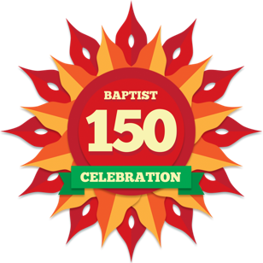
Mrs Menna Jones,
Undeb Bedyddwyr Cymru/Baptist Union of Wales,
Y Llwyfan,
Heol y Coleg/College Road
Caerfyrddin/Carmarthen SA31 3EQ
01267 245660

Enw/Name:
Eglwys/Church:
Cyfeiriad/Address:

Côd Post/ Postcode:

Rhif Ffôn/Telephone Number:

E-bost/E-mail:

Gellir defnyddio’r ffurflen hon ar gyfer archebion grŵp, ond bydd angen enw person cyswllt. Os ydych yn dod â phlant/pobl ifainc, rhaid nodi’u henwau a’u hoed ynghyd ag unrhyw anghenion arbennig, enw’r person cyfrifol a rhif ffôn cyswllt. Cofiwch sicrhau bod ffurflen caniatâd yn cael ei llenwi ar gyfer pob plentyn. Bydd ffurflenni ar gael ar gyfer plant sy’n dod gyda’u teuluoedd ar y diwrnod.
This form can be used for a group booking but we will need a contact name. If you are bringing children/young people, then please note their names and ages along with any special needs and the name of the responsible person with a telephone contact number in case of emergency. Please ensure that parents or guardians have completed a consent form for each child. Forms will be available for children coming on the day with their families.

Dydd Sadwrn/Saturday 17 Mehefin/June 2017 | Oedolion/Adults:  Tâl/Payment: £10 | Nifer/No. x £10 | =
Dydd Sadwrn/Saturday 17 Mehefin/June 2017 | Plant: dim tâl  Children: no payment required | Nifer/No. | =
 | Cyfanswm/Total:

Enwau’r Plant/Pobl Ifainc/  Names of Children/Young People | Oed/Age | Anghenion Arbennig/Special Needs
Enw a Rhif Ffôn y Person Cyswllt mewn achos o argyfwng / Name and Telephone Number of Contact Person in case of an emergency.
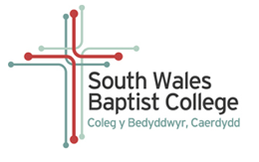
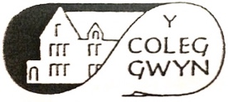
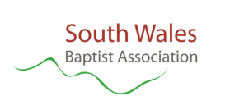

North Wales Baptist Union

